**Bài 1: Cho Database**

|  |
| --- |
| Create database [PMS]  GO  USE [PMS]  GO  /****** Object: Table [dbo].[Department] Script Date: 3/2/2020 4:57:51 PM ******/  SET ANSI_NULLS ON  GO  SET QUOTED_IDENTIFIER ON  GO  CREATE TABLE [dbo].[Department](  [id] [int] NOT NULL,  [name] [varchar](150) NOT NULL,  CONSTRAINT [PK_Department] PRIMARY KEY CLUSTERED  (  [id] ASC  )WITH (PAD_INDEX = OFF, STATISTICS_NORECOMPUTE = OFF, IGNORE_DUP_KEY = OFF, ALLOW_ROW_LOCKS = ON, ALLOW_PAGE_LOCKS = ON) ON [PRIMARY]  ) ON [PRIMARY]  GO  /****** Object: Table [dbo].[Employee] Script Date: 3/2/2020 4:57:51 PM ******/  SET ANSI_NULLS ON  GO  SET QUOTED_IDENTIFIER ON  GO  CREATE TABLE [dbo].[Employee](  [id] [int] NOT NULL,  [name] [varchar](150) NOT NULL,  [dob] [date] NOT NULL,  [gender] [bit] NOT NULL,  [did] [int] NOT NULL,  CONSTRAINT [PK_Employee] PRIMARY KEY CLUSTERED  (  [id] ASC  )WITH (PAD_INDEX = OFF, STATISTICS_NORECOMPUTE = OFF, IGNORE_DUP_KEY = OFF, ALLOW_ROW_LOCKS = ON, ALLOW_PAGE_LOCKS = ON) ON [PRIMARY]  ) ON [PRIMARY]  GO  INSERT [dbo].[Department] ([id], [name]) VALUES (1, N'IS')  INSERT [dbo].[Department] ([id], [name]) VALUES (2, N'IA')  INSERT [dbo].[Employee] ([id], [name], [dob], [gender], [did]) VALUES (1, N'mr A', CAST(N'2000-01-01' AS Date), 1, 2)  INSERT [dbo].[Employee] ([id], [name], [dob], [gender], [did]) VALUES (2, N'mr AA', CAST(N'2000-01-01' AS Date), 1, 1)  INSERT [dbo].[Employee] ([id], [name], [dob], [gender], [did]) VALUES (3, N'mr B', CAST(N'2000-01-01' AS Date), 1, 1)  INSERT [dbo].[Employee] ([id], [name], [dob], [gender], [did]) VALUES (4, N'mr BBB', CAST(N'2000-01-01' AS Date), 1, 2)  ALTER TABLE [dbo].[Employee] WITH CHECK ADD CONSTRAINT [FK_ Employee_Department] FOREIGN KEY([did])  REFERENCES [dbo].[Department] ([id])  GO |

Department

Id

name

Employee

Id

Name

Dob

Gender

did

/search

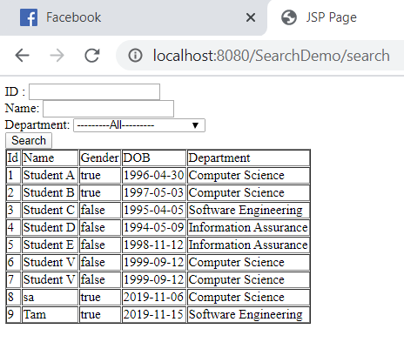

**Bài 2: Cho Database**

